Practicum No.11 Date: 27/2/2026
Vision, Mission, and Goal Setting
- Practical Significance
This practicum engages learners in articulating the vision, mission, and strategic goals for emerging technology ventures in domains such as Computer Science, Artificial Intelligence, Machine Learning, and Data Science. By clarifying purpose and direction, the exercise prepares students for industry environments where defining and communicating enterprise objectives is critical. Through this approach, students develop entrepreneurial discipline, foster stakeholder alignment, and position teams for sustainable growth—all of which are essential traits for modern startup leadership in competitive, rapidly changing sectors.
By engaging in this practicum, students will develop strategic thinking skills that enable them to align vision, mission, and goals effectively. They will gain the ability to translate entrepreneurial aspirations into actionable business plans with measurable outcomes. Learners will strengthen their decision-making and leadership capabilities through clear purpose-driven direction. Ultimately, they will acquire the competence to build sustainable ventures that balance innovation, ethics, and realistic goal achievement.

- Competency and Industry-Specific Practical Skills
This practicum exercise is expected to develop the following skills for the industry-identified competency.
- Develop a pitch deck, project proposals for small/medium scale startups logically and
scientifically (As stated in the Course Structure)
a) Assess the vision, mission, and strategic goals for a startup. (CDO)
b) Evaluate strategic management frameworks to align goals with organizational values. (CDO)
c) Function as an effective team leader and collaborator in planning exercises. (ADO)
d) Prepare structured business planning documents. (PDO)

- Relevant CO(s)(As stated in the Course Structure)
- CO4. Design a suitable business model and formulate financial plans for the selected product/service.

IV. Practical Outcome (PrO)((As stated in the Course Structure)
Draft vision, mission, and short/long-term goals for an identified CSE/AIML/DSCS/DS venture

V. Related ADO(s) (As stated in the Course Structure)

a) Perform as an effective team leader.
b) Function as a cooperative team member.
c) Demonstrate ethical decision-making and critical thinking in business planning.
d) Exhibit professionalism in documentation and presentation standards.

VI. Minimum Underpinning Theory (Include relevant content & images for this practicum.)

Vision and mission statements are central elements of strategic management that communicate an organization's identity and purpose. The vision statement defines the desired future state of the enterprise—an aspirational declaration of what the organization seeks to become or achieve in the long run. It serves as a North Star, guiding strategic decisions and inspiring stakeholders. The mission statement, on the other hand, outlines the organization's present objectives, core activities, and the approach it takes to achieve its vision. Together, they create organizational coherence, inform key decisions about market positioning, operations, culture, and resource allocation.
In the context of entrepreneurship, clarity of vision and mission is vital for startups navigating competitive, resource-constrained, and dynamic environments. A well-articulated vision attracts investors, partners, and talent by clearly communicating the startup's purpose and potential impact. The mission ensures operational focus, defining what the business does, whom it serves, and how it creates value. Strategic goal-setting further strengthens this foundation by breaking down ambitions into achievable milestones:
- Short-term goals (0-1 year): Focus on foundational activities such as legal registration, product/service prototyping, initial customer acquisition, and market validation.
- Medium-term goals (2-3 years): Emphasize scaling operations, expanding customer base, forming strategic partnerships, securing certifications, and attracting investment.
- Long-term goals (5+ years): Aim for industry leadership, innovation excellence, market dominance, international expansion, and sustainable profitability.
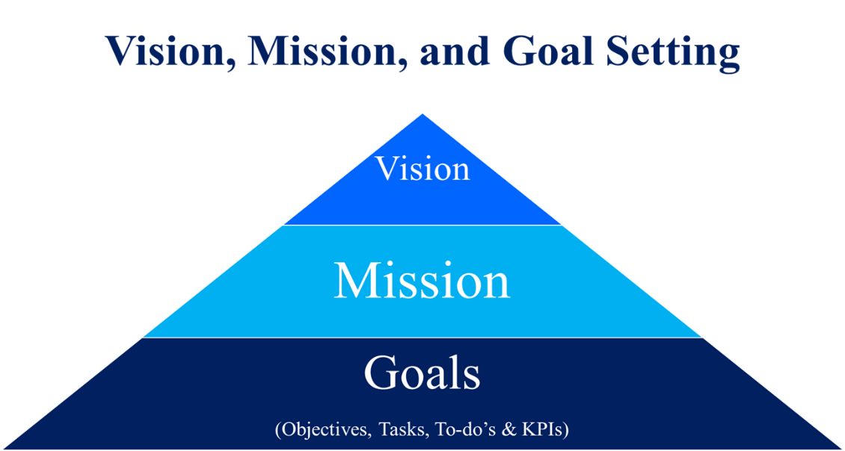

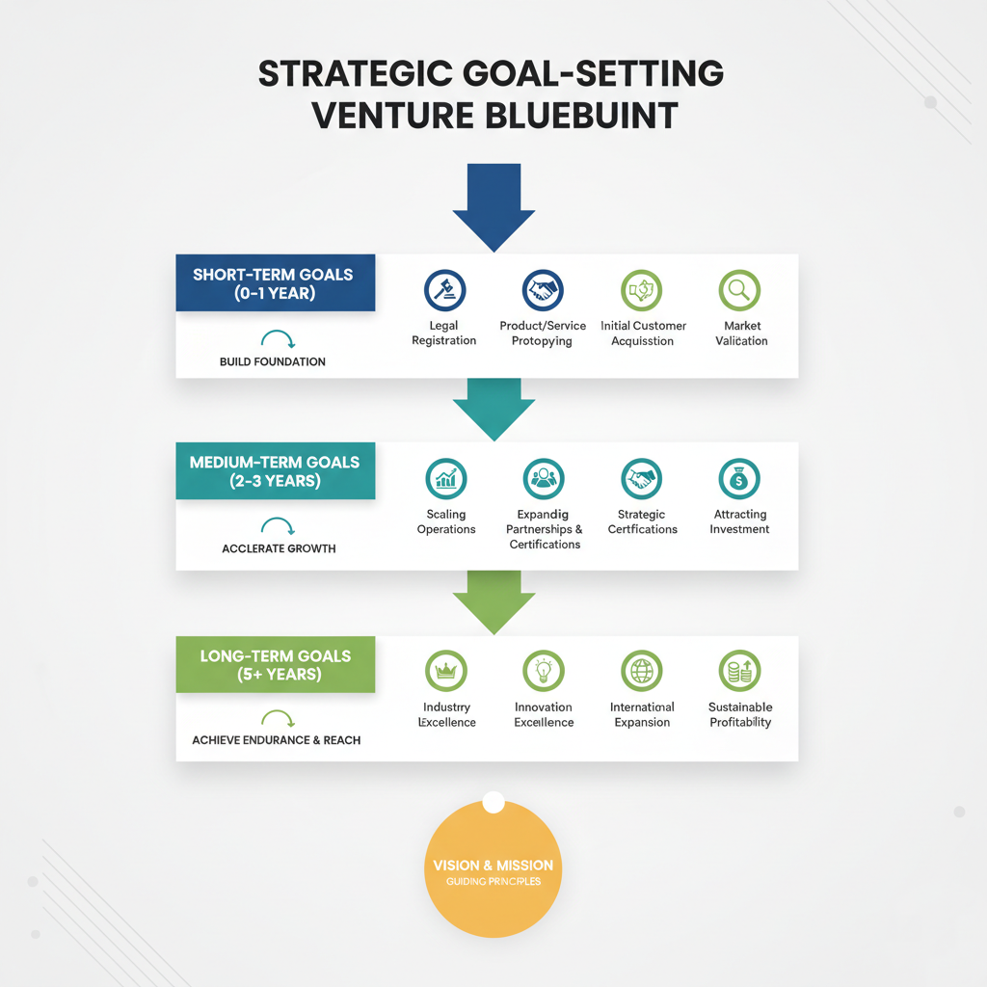

Frameworks such as SMART Goals (Specific, Measurable, Achievable, Relevant, Time-bound), Balanced Scorecard (financial, customer, internal process, learning & growth perspectives), and SWOT Analysis (Strengths, Weaknesses, Opportunities, Threats) are applied to ensure that objectives are measurable, realistic, and strategically aligned with the startup's vision and mission.

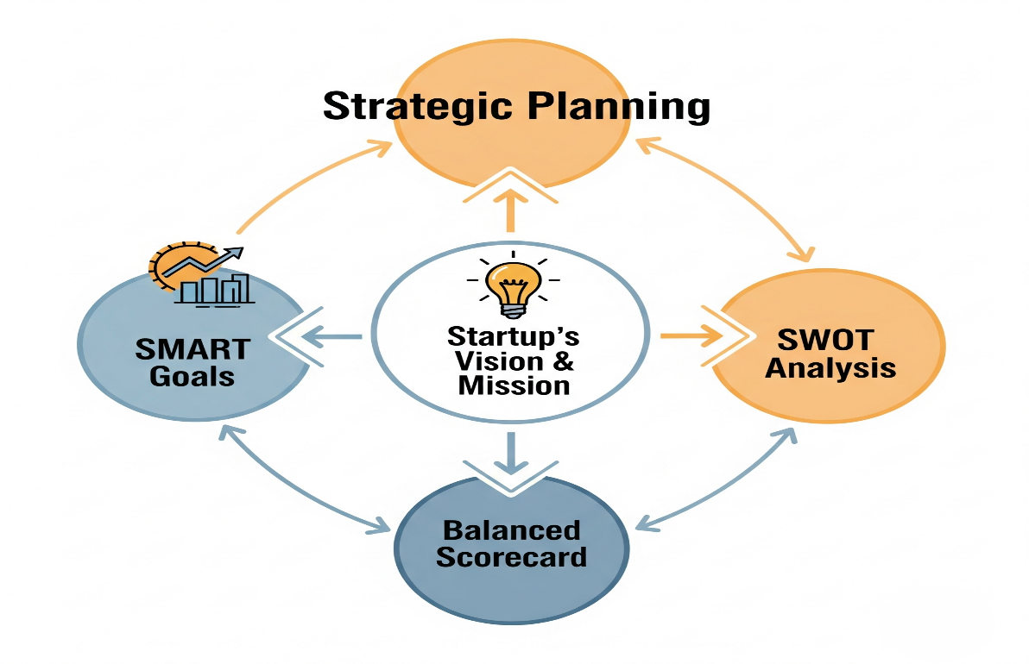

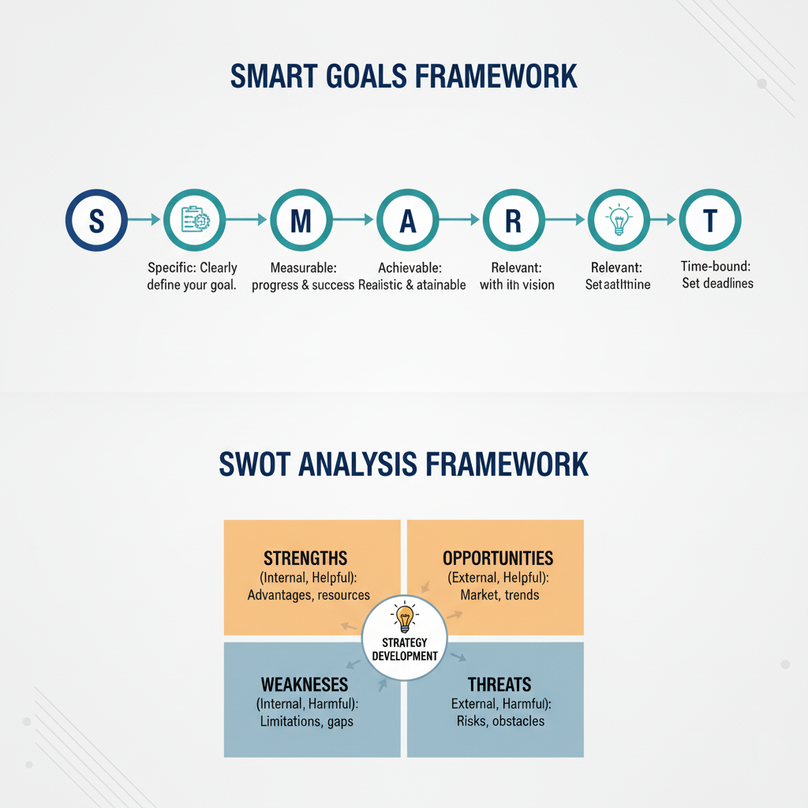

VII. Practicum Set-up/Circuit Diagram/Algorithm/Flowchart (Include probable photos of experimental set-up.)

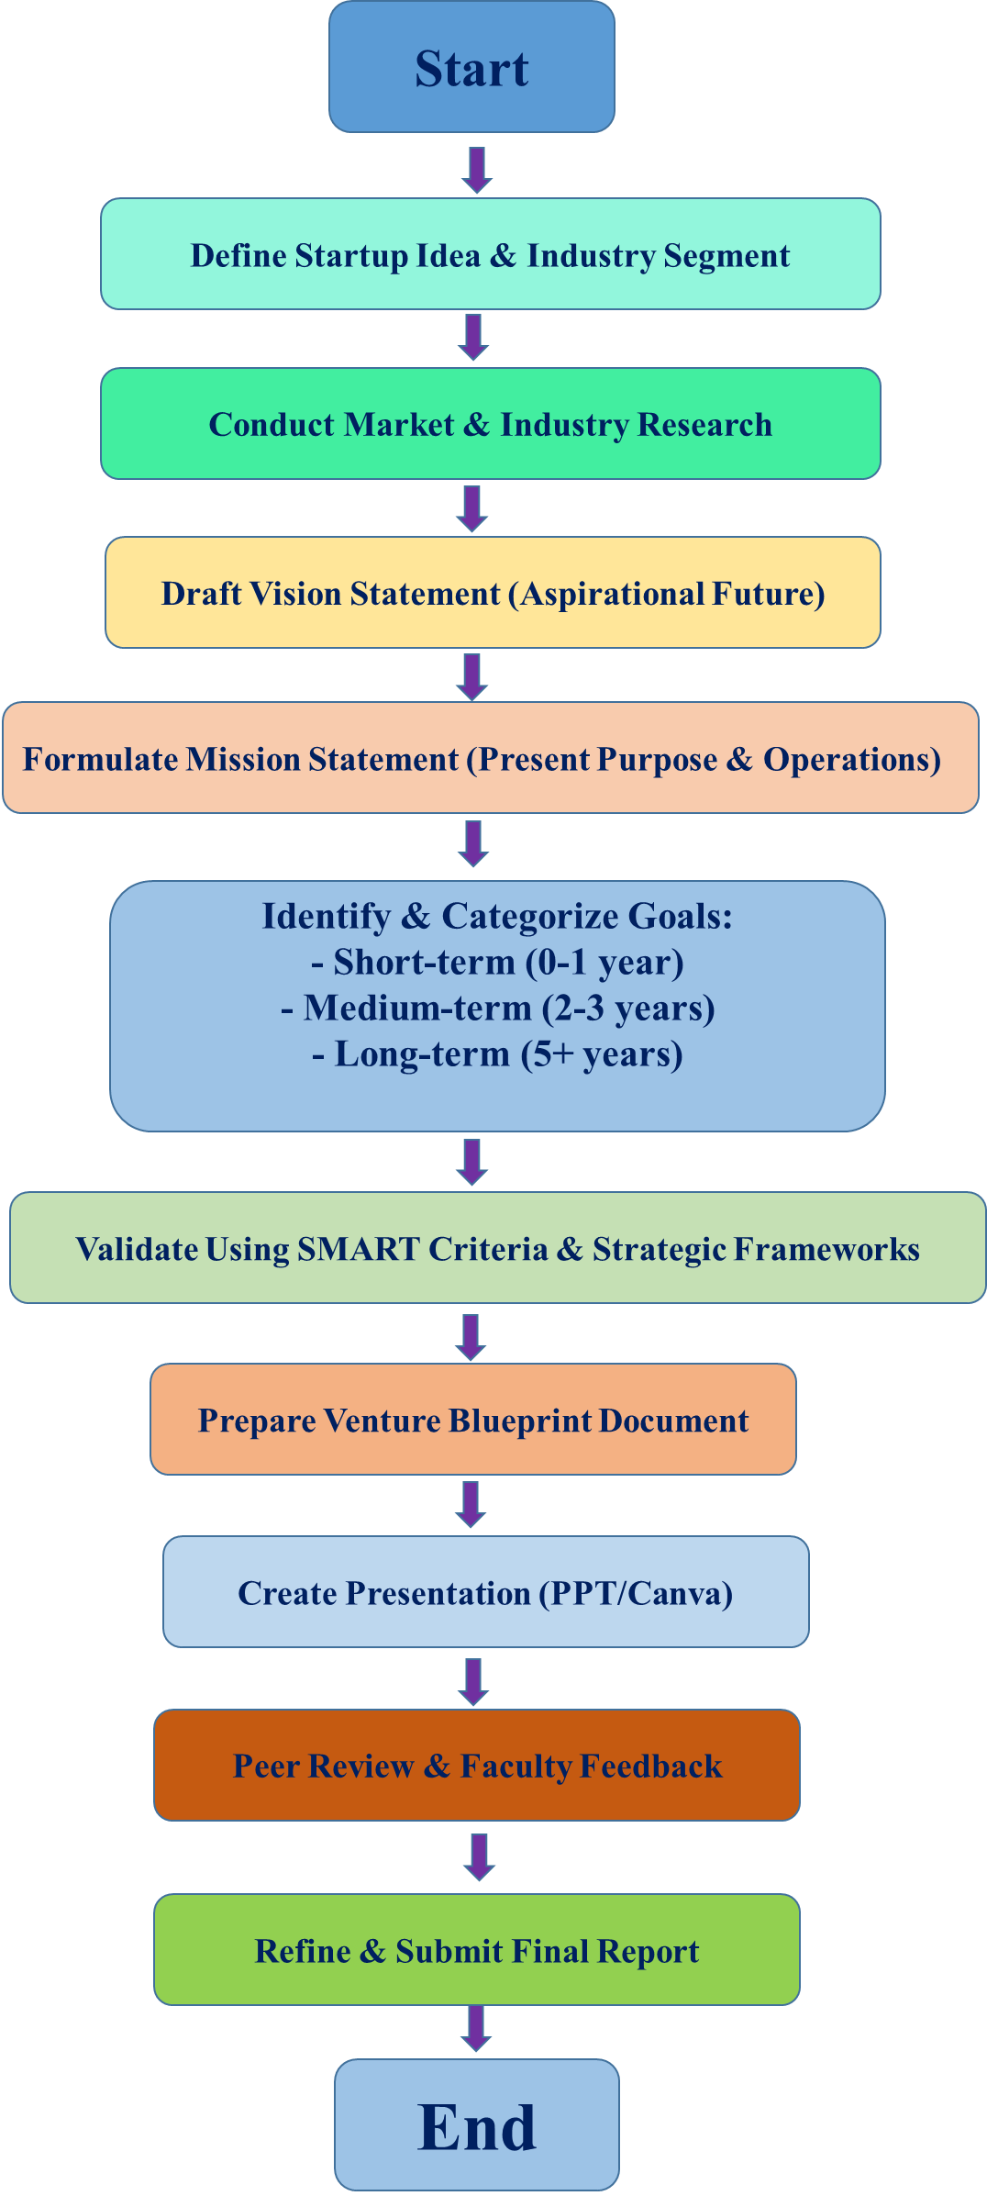

VIII. Resources Required

S. No. | Resource | Suggested Broad Specification | Quantity
1 | Computer/Laptop | MS Office/Google Docs, Canva/PowerPoint | 1
2 | Reference Material | Case studies of successful startups, vision/mission templates, industry reports
3 | Internet Access | For researching industry trends, competitor analysis, startup examples
4 | Projector/Screen | For presentation of venture blueprint
5 | Whiteboard/Flipcharts | For brainstorming and collaborative planning sessions

IX. Safety Precautions

a) Ensure that all statements reflect ethical, realistic, and socially responsible objectives.
b) Avoid copying vision/mission statements from existing enterprises; originality is essential.
c) Maintain confidentiality of startup ideas, proprietary information, or sensitive business data.
d) Use professional formatting, grammar, and appropriate business language in all documents.
e) Respect intellectual property rights when referencing external sources or case studies.
.
X. Procedure(Self-Instructional)

- Choose a practical startup idea that solves a real market problem.
- Research the industry to understand trends, demand, and competition.
- Draft a clear and inspiring vision statement for the next 5–10 years.
- Frame a mission statement defining purpose, target, and approach.
- Set short-, medium-, and long-term goals for business growth.
- Validate goals using SMART (Specific, Measurable, Achievable, Relevant, Time-bound) criteria.
- Apply SWOT and Balanced Scorecard tools for strategic planning.
- Prepare a concise venture blueprint with key objectives and timelines.
- Design a visual presentation highlighting the main points.
- Present your blueprint, gather feedback, and make improvements.
- Submit the final, polished report on time as per guidelines.
XI. Actual Resources Used

S. No. | Name of Resource | Broad Specifications |  | Quantity | Remarks  (If any)
 |  | Make | Details
 | Laptop | ASUS | Windows OS, 8GB RAM used for preparing the startup planning document | 1 | N/A
 | Internet | Wi-Fi | Used for research and accessing Miro templates | 1 | N/A
 | Browser | Chrome | Used to open online templates and reference materials | 1 | N/A
 | Online Templates | Miro | Vision, Mission, and SMART Goals templates used for structuring the startup plan | 1 | N/A

- Actual Procedure Followed

- Selected Digital Attendance and Productivity Tracker as the startup concept based on the mini-project idea.
- Studied the concepts of vision, mission, and goal setting to understand how startups define their long-term direction.
- Used Miro Vision–Mission–Goals templates to organize and structure the startup planning process.
- Drafted a vision statement describing the long-term goal of improving attendance management and productivity tracking in educational institutions using digital technology.
- Prepared a mission statement explaining how the system provides an automated platform for recording attendance and monitoring productivity for students and teachers.
- Defined short-term, medium-term, and long-term goals focusing on system development, implementation in institutions, and scaling the product.
- Applied the SMART framework to ensure that each goal was specific, measurable, achievable, relevant, and time-bound.
- Organized all planning elements clearly and prepared a structured document including the vision, mission, and SMART goals for the startup.
- Observations

S.No. | Step in Practicum | Case studies/LMS analytics/rubrics for Team works /Instructor Evaluation Forms | Observation Details | Remarks
1 | Idea Selection | Digital Attendance and Productivity Tracker identified as a solution for improving attendance management | Practical educational solution | Idea Selection
2 | Research | Studied digital attendance systems and productivity monitoring tools | Opportunity for improvement | Research
3 | Vision & Mission Drafting | Vision focuses on improving academic management using digital technology | Clear long-term direction | Vision & Mission Drafting
4 | Goal Setting | SMART goals defined for product development and adoption in institutions | Realistic and achievable | Goal Setting

- Results/Observations

The Digital Attendance and Productivity Tracker startup concept addresses the challenge of manual attendance tracking and lack of productivity monitoring in educational institutions. The vision, mission, and SMART goals clearly define the purpose and strategic direction of the startup. The planning process shows that the idea has potential for practical implementation and scalability in schools and colleges.

- Interpretation of Results

The results show that having a clear vision, mission, and well-defined goals is important for startup planning. The vision provides long-term direction, the mission explains the purpose and value of the product, and the SMART goals guide the development and implementation process. This structured planning approach helps startups remain focused and improves decision-making.

- Conclusions

The Digital Attendance and Productivity Tracker is a practical startup idea that can improve attendance management and academic productivity in educational institutions. The alignment of vision, mission, and SMART goals provides a clear roadmap for future development. With proper implementation and adoption, the system can expand to multiple institutions and become a useful digital solution in the education sector.

- Suggested Practicum Related Questions:
Note:Below are a few questions related to industry-specific higher-order thinking skills (HOT) that teachers must use to ensure students achieve the predetermined course outcomes.
- Analyze how a medical startUp’s vision aligns with current global trends in digital health innovation.
- Evaluate the effectiveness of medical startUp’s mission in addressing patient accessibility and affordability challenges.
- Apply SMART goal criteria to assess whether medical startUp’s short-term goals are realistically achievable.
- Create a business model canvas for medical startUp’s demonstrating the integration of technology, market, and customer value.
- Analyze the potential risks and ethical challenges associated with deploying AI-based patient monitoring systems.
- Apply strategic planning tools SWOT to identify medical startUp’s competitive positioning.
- Evaluate the impact of long-term goals on medical startUp’s scalability and sustainability in the healthcare market.
- Create a Balanced Scorecard to measure medical startUp’s progress across financial, customer, internal, and innovation perspectives.
- Analyze stakeholder expectations and propose strategies for maintaining trust and data transparency in medical startUp operations.
- Evaluate how medical startUp can adapt its mission and vision to align with future technological disruptions in telehealth.
- References / Suggestions for further reading

a) Entrepreneurship Development (NPTEL Course)
https://nptel.ac.in/courses/110/107/110107152/
b) Strategic Management and Business Policy (NPTEL Course)
https://nptel.ac.in/courses/110/108/110108047/
c) How to Write a Vision and Mission Statement (YouTube – Harvard i-lab)
https://www.youtube.com/watch?v=example
d) Business Model Canvas Explained (Strategyzer)
https://www.strategyzer.com/canvas/business-model-canvas
e) SMART Goals: How to Make Your Goals Achievable (MindTools)
https://www.mindtools.com/pages/article/smart-goals.htm
f) The Lean Startup by Eric Ries (Book)
g) Vision and Mission Statements – Best Practices (Coursera)
https://www.coursera.org/learn/strategic-planning

- Suggested Assessment Scheme
The performance indicators given serve as a guideline for assessing the‘process-related skills/LOs’ (marks to be awarded in real-time in the laboratory by the faculty member, as these cannot be measured after the practicum is over) and ‘product-related skills/LOs’

Note: The weightage for theprocess-related skills and product-related skills will change depending on the PrO, COs, and the competency related to the concerned course.
Performance Indicators |  | Maximum Marks | Marks Obtained
Process relatedskills: 12 Marks - 40%
1 | Research & Market Analysis | 3
2 | Team Collaboration & Leadership | 3
3 | Strategic Framework Application (SMART, SWOT, BSC) | 3
4 | Presentation Skills & Communication | 3
Product related skills: 18 Marks - 60%
1 | Quality & Clarity of Vision Statement | 3
2 | Quality & Clarity of Mission Statement | 3
3 | Relevance & Achievability of Goals (Short/Medium/Long-term) | 4
4 | Strategic Alignment & Coherence | 3
5 | Document Quality, Formatting & Professionalism | 3
6 | . Timely Submission | 2
Total |  | 30

To be filled by Student:

S.No. | Name of the Student | Register No.
1 | Neavis Rishva. J | URK25CS1236

To be filled by the Faculty Member:
Marks Obtained |  |  | Name and Designation of the Faculty Member | Date of Evaluation
Process-Related Skills  (18) | Product-Related Skills (12) | Total  (30)

*******

